***SOFTWARE REQUIREMENTS SPECIFICATION***

**Applicant Tracking System (ATS)**

**Team Members:**

Sandeep Kumar Torlikonda

Nikhil Chandra Raj

Rakesh Varma Samala

1. **Introduction**

An ATS-Applicant Tracking System is a software application that enables the handling of the hiring and recruitment processes and needs. An ATS can be implemented or accessed online at the enterprise- or small-business level, depending on the needs of the organization.

A dedicated ATS is not uncommon for recruitment-specific needs. On the enterprise level, it may be offered as a module or functional addition to a [human resources](https://en.wikipedia.org/wiki/Human_resources) suite or human resource information system (HRIS). The ATS is expanding into [small and medium enterprises](https://en.wikipedia.org/wiki/Small_and_medium_enterprises) through [open-source](https://en.wikipedia.org/wiki/Open-source_software) or [software-as-a-service](https://en.wikipedia.org/wiki/Software_as_a_service) offerings (SaaS).

* 1. Goals and Objectives

The principal goal of our ATS is to provide a central location and database for a company’s recruitment process with the objective of better assisting the management of resumes and applicant information. Data is collected from internal applications via the ATS front-end, located on the company website, or extracted from applicants on job boards. Most jobs and resume boards have partnerships with ATS software providers to provide parsing support and east data migration from one system to another.

* 1. Statement of Scope

An [applicant tracking system (ATS)](https://www.jobvite.com/products/applicant-tracking-system/) helps companies organize and track candidates for hiring and recruitment purposes. These systems allow businesses to collect information, organize prospects based on experience and skill set, and filter applicants.

[More than 90% of Fortune 500 Companies](https://medium.com/swlh/90-of-fortune-500-companies-use-an-applicant-tracking-system-whats-it-5a6b6d25e5e7) are currently using an ATS. While these systems are excellent for storing candidate information, the best applicant-tracking systems can track all communications with candidates. This makes it easy to search and filter resumes and other candidate information, decreasing time-to-fill and ensuring that companies get the best candidates for the position.

In contemporary times, where thousands of resumes are screened on a daily basis in order to hire the best talent, it becomes very difficult to manage, organize and maintain the workflow effectively and efficiently, so in this case, an Applicant Tracking System plays a major role.

* 1. Software Context

Candidates are looking for application processes that are easy, fast, and user-friendly and they apply to some job sites, and we use that resumes in order to meet the needs of the organization. This means that companies benefit from a larger pool of applicants, which can then be ranked automatically based on skills and experience.

During the recruitment process, applicant tracking systems allow recruiters to review and screen a candidate easily.

* 1. Major Constraints

Our ATS is available on the internet and can be accessed anywhere with a good internet speed. Though it is a Human Resource specified software it may contain some technical terms and jargon that can only be understood by recruiters and human resource professionals.

**2.0 Usage Scenario**

The process of searching, screening, and hiring candidates has transformed around internet search technology and Automation. With the entire [workforce](https://techrseries.com/?s=workforce+&btnSubmit=) taking the online route to search for and apply for jobs, organizations need to stay in sync in terms of speed and efficiency.

When too many job-seekers apply for a job, sifting through their resumes and sorting out the best fit for the available role becomes a tedious and time-consuming task. While the process used to be manual in nature in the past decades, [HR technology](https://techrseries.com/?s=HR+technology&btnSubmit=) has evolved enormously. ATS streamlines the hiring process to a great extent, offering numerous solutions for various recruiting goals and challenges.

2.1 User Profile & Use-cases

A large organization who have to hire a large number of candidates for their company in a frequent manner, and has a large team of recruiters and managers, can use ATS in order to make a proper workflow and efficient database for the same.

For a consultancy firm, it is a must to have management and organization of the resumes database across all the recruiters, and an ATS solved this problem.

The whole hiring process is tedious, right from screening and onboarding there are various steps taken, and maintaining all these in the database is also very difficult, so in that case, with the help of an ATS we can manage and organize all the processes

2.2 Special usage considerations

The user must have a stable internet connection with the knowledge of human resources.

**3.0 Data Model and Description**

3.1 Data Description

3.1.1 Data Objects

We are majorly using Character and Integer data types in order to perform and store all the data that are essential. Character data type is used to store all inputs that are in string format like Names, Published Site names. Integer data types are made in order to record the numerical values like phone numbers. Apart from this we have used datetime object to store all the data that require date format like job posted date and many more.

3.1.2 Relationships

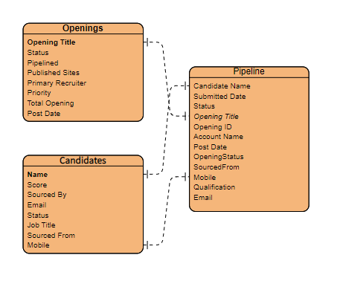

**4.0 Functional Model and Description**

4.1 Description of Major Functions

4.1.1 Dashboard

In the dashboard page, we can see the on the go details about the openings and total number of the openings of the specific user.

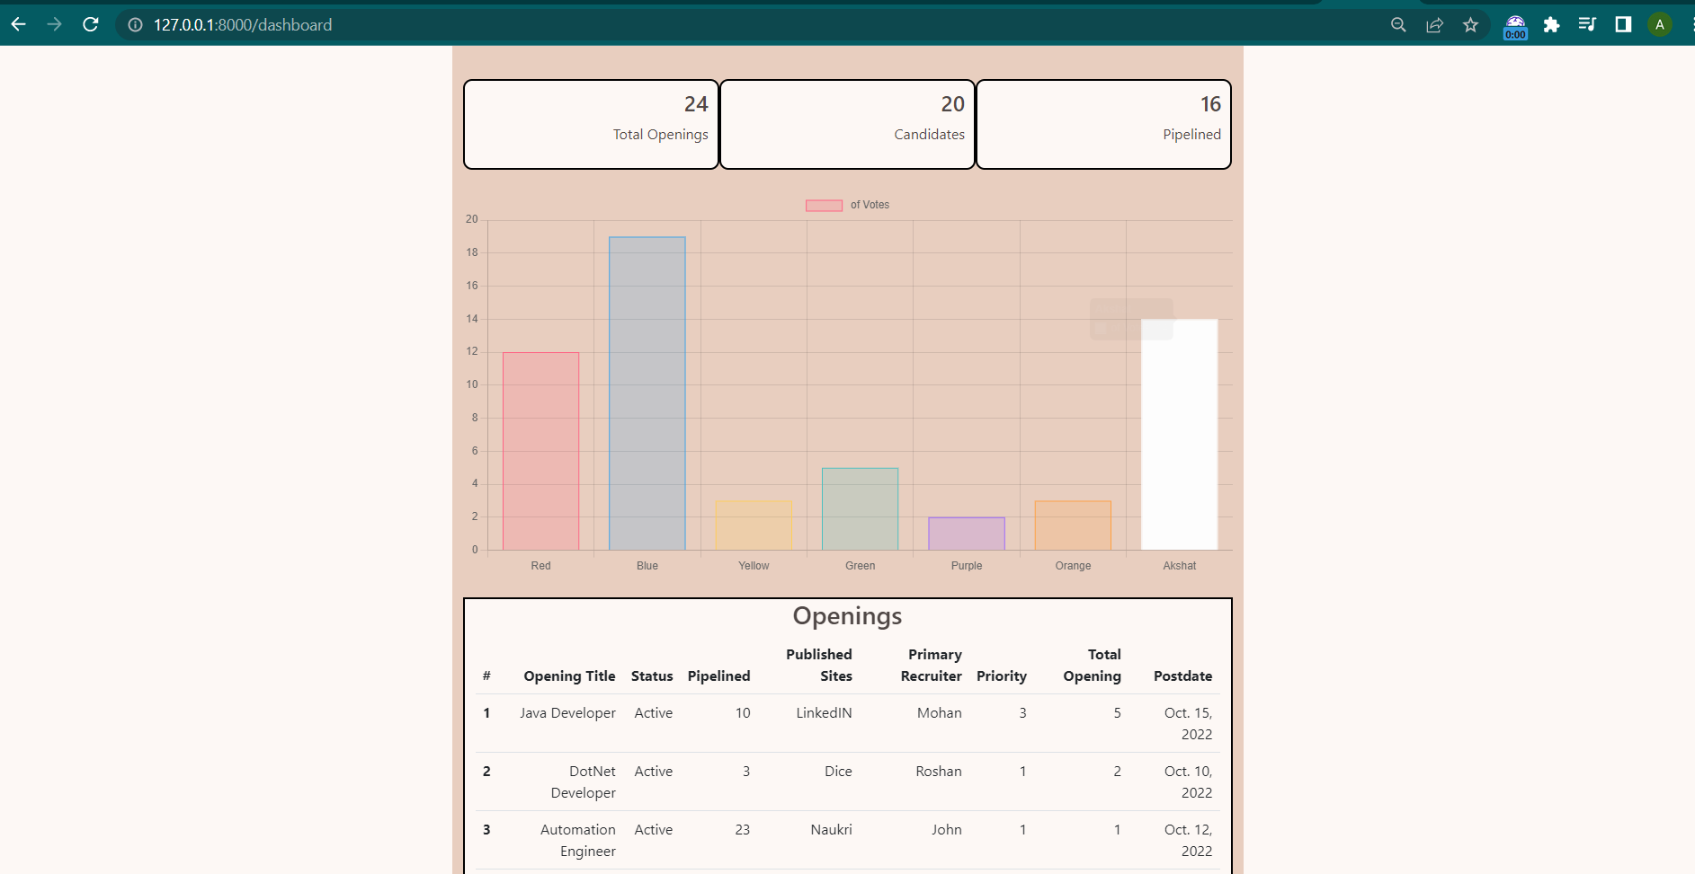

4.1.2 Openings

This page shows all the job opening that has been made in the organization for which the candidates are to be hired. It gives various information related to the openings such as status, pipelined, etc.

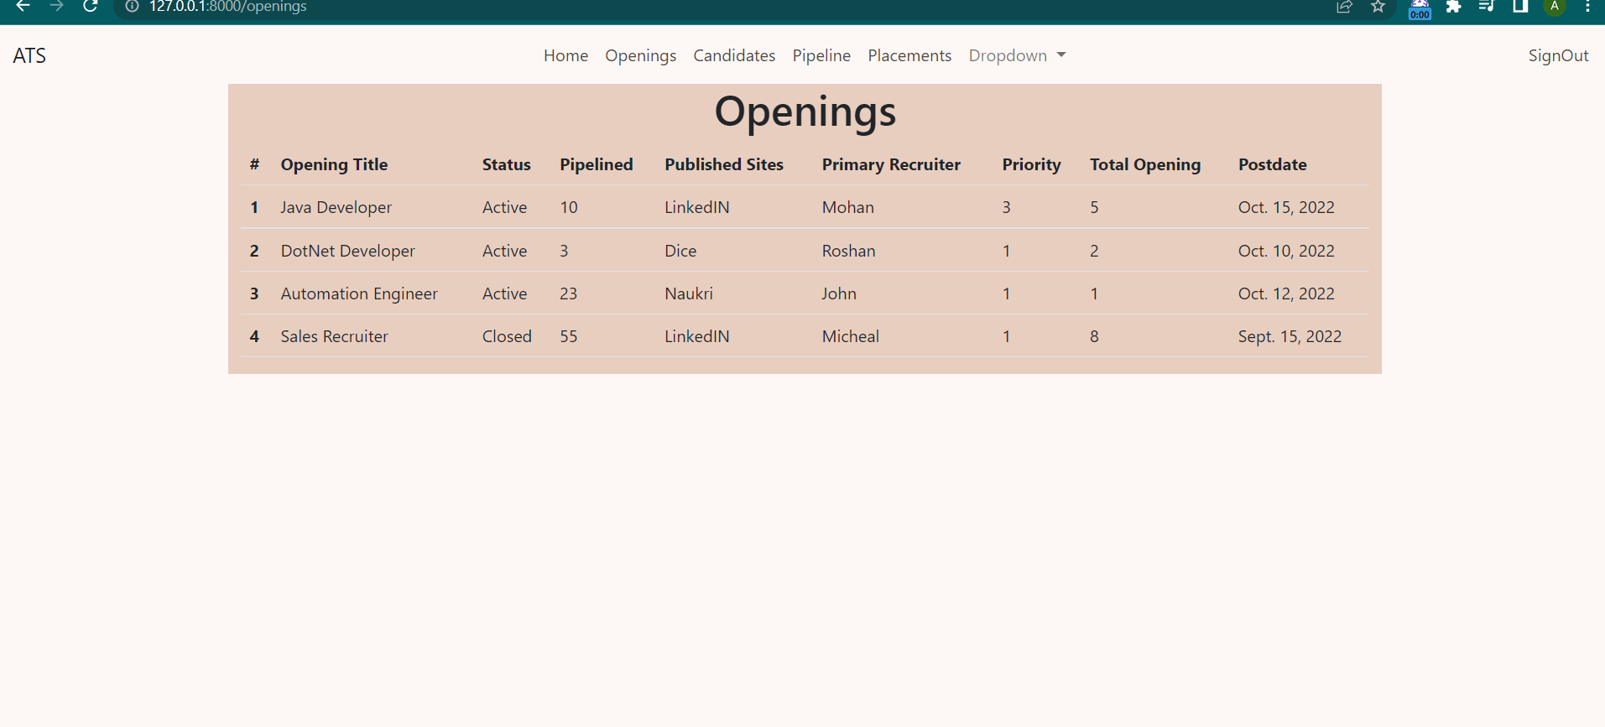

4.1.3 Candidates

It contains all the information about the candidates that have being screened by the candidates.

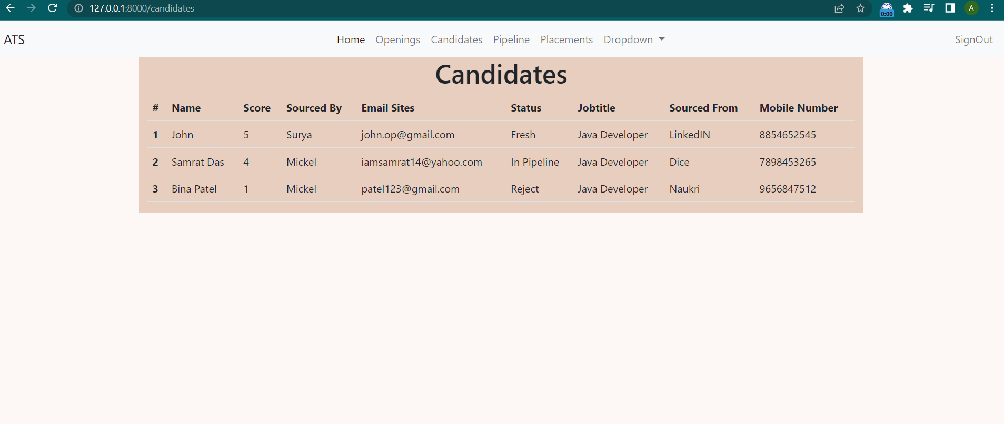

4.1.4 Pipeline

It contains all the information about all the candidates that have being pipelined.

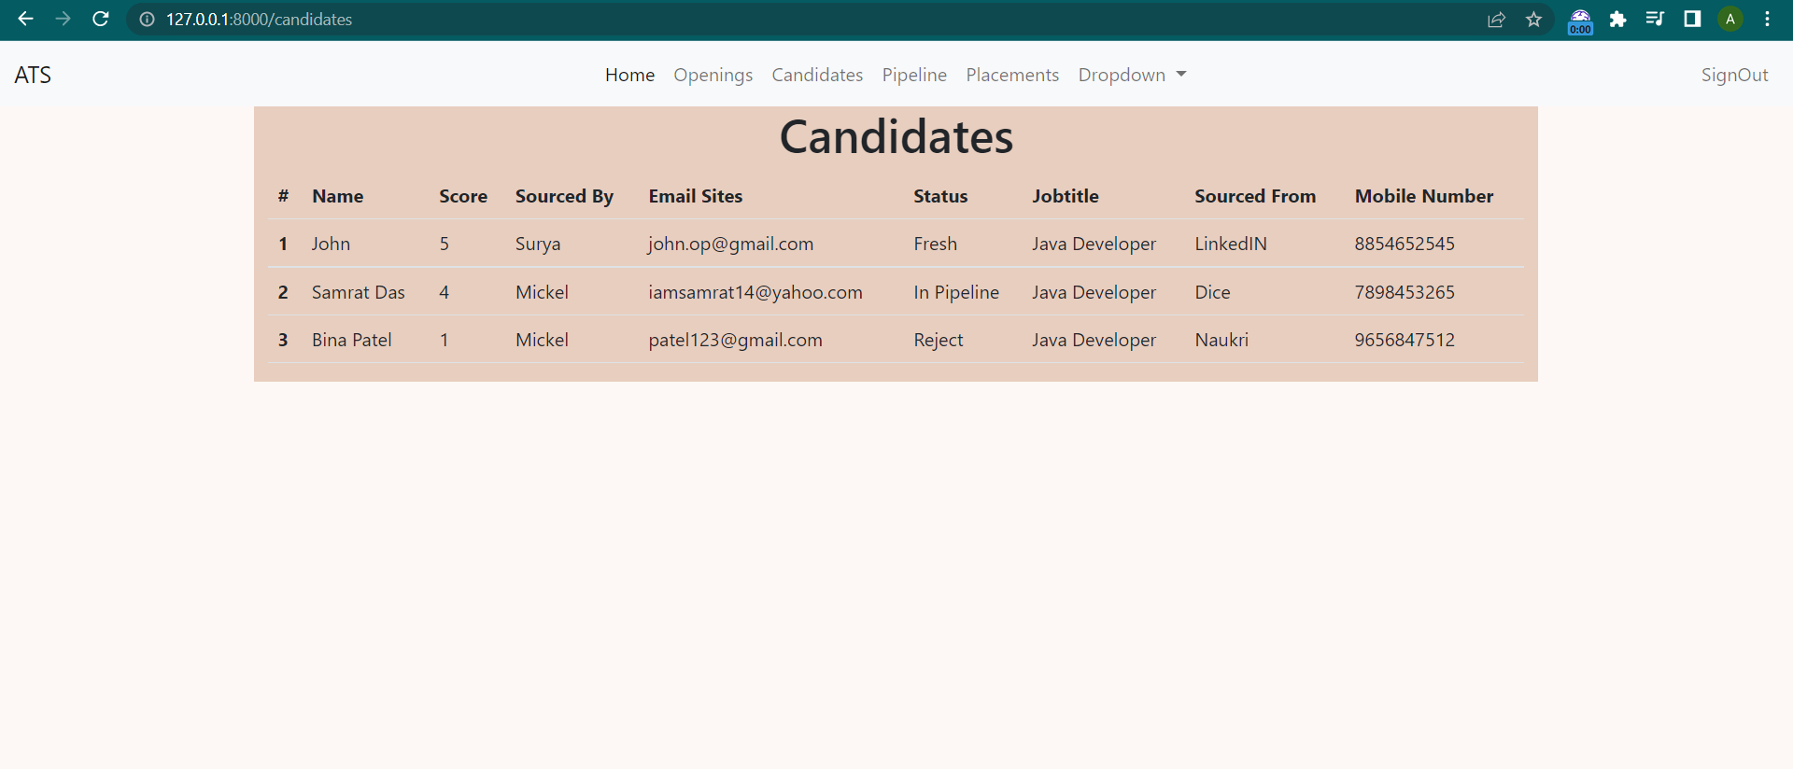

4.1.5 Placements

This page shows all the information about the candidates that have been hired or placed.

